Make to Innovate Final Report
Josh DeLarm, Ethan Harstad, Josh Boyer, Alex Maxwell, CJ Monks, Nolan Van Rossum, Brian Hageman, Timothy Miner

May 3, 2013
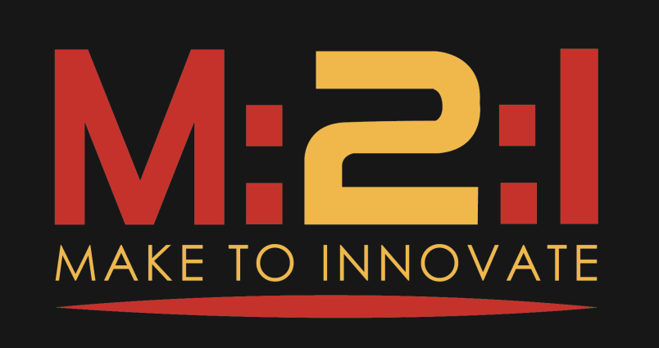

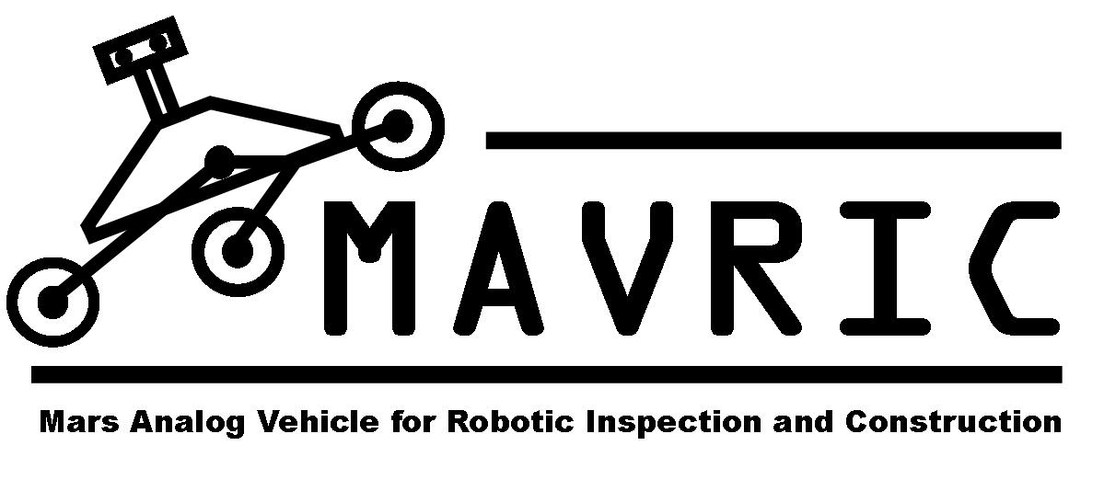

Abstract
This report details aspects of the student-led group called MAVRIC (Mars Analog Vehicle for Robotic Inspection and Construction). It covers the background of the project, goals of the project, as well as the tasks that the group is asked to complete. In addition, project milestones, current progress, and future plans can also be found in this report.

This final report is submitted in partial fulfillment for the Make to Innovate (M:2:I) program at Iowa State University in the Aerospace Engineering department and in part for their grade in AerE 290C or AerE 490E. The author(s) hereby state that the information submitted in this report is accurate to the best of their knowledge.

Contents
Make to Innovate Final Report 1
Contents 3
Part I — Overview 3
1 Background 3
2 Project Goals 4
2.1 Competition Goals 4
2.2 Project Goals 4
Part II—Project Definition 5
1 Project Milestones 5
Part III—Project Results 6
1 Finished items 6
1.1 Solidworks Model 6
1.2 Suspension Construction 6
1.3 Wheel Construction 7
1.4 Chassis Construction 8
1.5 Robotic Arm 8
1.6 End Effector 8
1.7 Gearbox Design 8
Part IV—Conclusion 9
1 Future Work 9

Part I — Overview
MAVRIC is a student lead project aimed at creating a simulated Mars rover for a competition held in Hanksville, Utah every summer. Students design, fabricate, and test the rover and various necessary sub-systems needed for a fully functioning rover. The project offers a unique opportunity to introduce engineers-in-training to the principles they will have to utilize on a daily basis in an industry setting. Communication skills, presentation skills, team working skills, as well as the design and fabrication skills learned while being part of this project are vital to the future success of the student engineers.

1 Background
MAVRIC has existed as a project of the Make to Innovate program (M2I) for going on roughly six years now. Throughout those years, there have been many iterations of rovers that encompassed different design ideas. The team of this year was a completely new team and wanted to take a new approach to the project. The idea was to change the way the project as a whole operated. Instead of doing a new rover each and every year, the idea was to create a platform that was so well designed and suited to the task at hand that future semesters could simply add to the rover and work towards increasing its performance.

2 Project Goals
MAVRIC has a couple sets of goals as a project. One set in specific is targeted to the rules of the competition and aims at overcoming those. The other set of goals targets what the current team wishes to improve over previous years in the area of design.

2.1 Competition Goals
The competition that MAVRIC is aimed at attending is called the University Rover Challenge (URC) and is put on by the Mars Society. Like any competition, there are rules and tasks that are required to be completed. MAVRIC is tasked to complete five tasks in total. These tasks are as follows:
• Task one is a presentation task in which the team is asked to put on a formal presentation describing the rover and its functionality, as well as the team and its structure.

• Task two requires the team to remotely operate the rover in order to obtain a subsurface soil sample from an area deemed by the team to contain biological life. The sample must then be tested in an onboard test as well as tested again at the command station to determine if any biological life exists in the sample.

• The third task, deemed the Astronaut Assistance Task, is aimed at testing the ability of the rover to pick up and drop off packages of various sizes to simulated Astronauts, given rough GPS coordinates. The rover will be required to pick up packages weighing up to 5 kg a piece.

• Equipment servicing is the fourth task that the rover must complete. This task involves using a robotic arm remotely to operate switches, levers, and various 2” PVC fittings in an order determined by a set of directions that will be posted near the task location.

• The fifth and final task involves being able to traverse terrain that the rover would encounter if actually on Mars. This task is set up so that the rover will encounter various terrains of varying difficulties along a predetermined path. To complete this task, the rover must successfully travers this terrain in the allotted time.

2.2 Project Goals
In addition to Competition goals, MAVRIC also holds a set of project-related goals. These goals are what the group as a whole would like to see in the project. These elements go beyond the requirements of the competition and encompass the ideals that make up MAVRIC.
- Design a rover capable of doing all the tasks required by the URC.
- Create a rover platform that can be used for multiple years rather than just one.
- Create a learning opportunity for members that will better prepare them for the job market.
- Strengthen skills in member communications, teamwork, and leadership.

Part II—Project Definition
Specifically, MAVRIC is tasked with designing a rover with components and sub-systems that satisfy the requirements of the URC tasks. These include being able to obtain a subsurface soil sample, being able to traverse rough terrain, being able to manipulate switches and buttons as well as clean a solar panel, and being able to drop off payloads to simulated astronauts. In addition, MAVRIC is tasked at an internal level to provide a positive learning environment for student engineers as well as strengthen and develop skills they will need in the future.

1 Project Milestones
MAVRIC, as a team, has determined a few milestones to gauge the accomplishment of the team goals.
- Fully Design Rover – This is the logical first step in completing a large-scale design of this nature. The basic ideas must be talked through and sketched out. Upon completion of that, 3D models need to be made in order to ensure all parts and systems are working in unison, the way they were designed to.
- Complete Chassis Construction – The chassis in this case refers to the suspension system in conjunction with the chassis itself. These two sub-systems make up the platform on which everything else is mounted and therefore are the first sub-systems that need to be implemented.
- Driving Chassis – Driving is arguably one of the most important aspects of the entire project. Without the ability to move, the rest of the sub-systems cannot function as designed. In order to drive, electronics need to be integrated with the mechanical systems and in addition have to work together correctly.
- Fully Integrated Sub-systems – The tasks that MAVRIC’s rover is to complete require several specialized tools. Each tool or assembly of tools makes up a sub-system. These sub-systems are as follows: the payload deployment mechanism, the robotic arm, the end effector, the soil sampling attachment, as well as the solar panel cleaning tool. It is tantamount to the group’s success at competition that each sub-system works as designed and has had adequate testing.
- Testing – In addition to the testing necessary for the sub-systems, the entire rover needs to be tested. This includes being able to use all sub-systems in a manner consistent with design criteria, being able to drive in addition to using tools, as well as being able to do all this remotely from the remote command station.
- Attend Competition – This is the purpose that the rover was designed, built, and tested for. This signifies the culmination of successes from all the previous goals, and thusly means the group did what it set out to do.

Part III—Project Results

1 Finished items

1.1 Solidworks Model
It was decided that the rover needed to be remanufactured to eliminate tolerance errors seen in the previous model. The new design utilized billet material that was donated to the group by the Aerospace department of Iowa State University. The new design has a higher tolerance and more rigid overall construction.

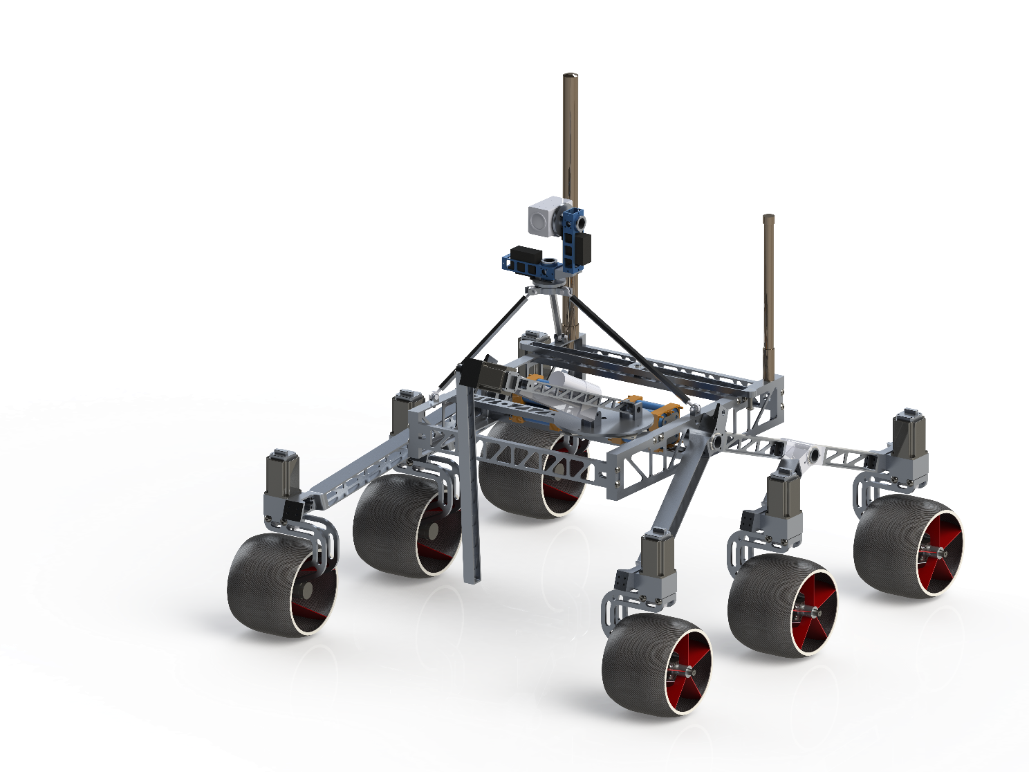
Figure 1: The overall rover model utilizes billet material and CNC machining in order to provide a precise and lightweight design.

1.2 Suspension Construction
Last year’s suspension design was a hand fabricated Rocker-Bogie system. However, due to low quality construction methods, the suspension system from last year needed to be remade. Since last year’s design, the team gained CNC milling experience as well as a donation of billet material. These two changes in addition to the need for a new suspension system lead the team to do a complete redesign that utilized CNC machined components. This not only allowed for a higher degree of precision in the parts, but also allowed for a stronger and lighter design to be manufactured. In addition to these benefits, there were also a great deal of other beneficial features added.

One of the best features of the new design was that it utilized components that could be used on either the right or left suspension sides. This modularity ensured that if a component broke, it could be replaced easily and that a single replacement part could be used on either side of the suspension. The previous rover did not have this capacity. This meant that if a component broke, that a very large part of the suspension had to be remade. It also meant that if a replacement part was desired, it would be very large and hard to store.

An additional benefit to the new suspension design was preplanned electronic board mounting locations and wire routing. The old model did not contain predetermined locations for board mounting or for wire routing. The newer model incorporated hollow pins at all the joint locations so that wires could be routed through them. This ensured that the wires would not be pinched or severed when the suspension system was in motion. This also allowed for the wires to be hidden in order to increase the aesthetic appeal of the rover as a whole.

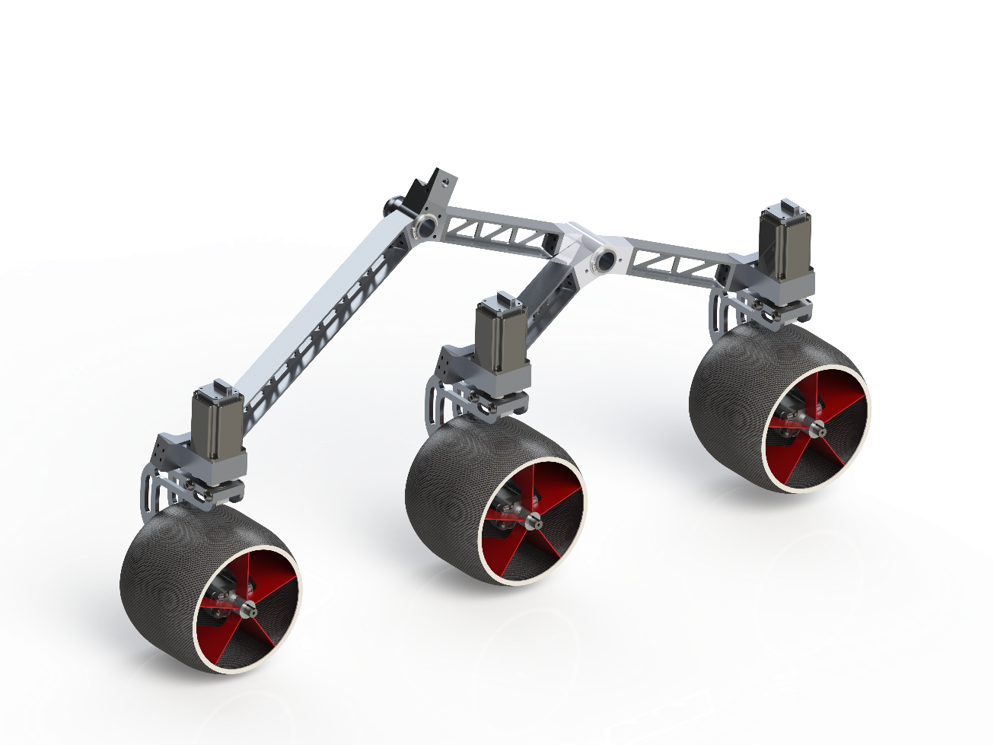
Figure 2: Model of MAVRIC’s new suspension design that utilized CNC machining.
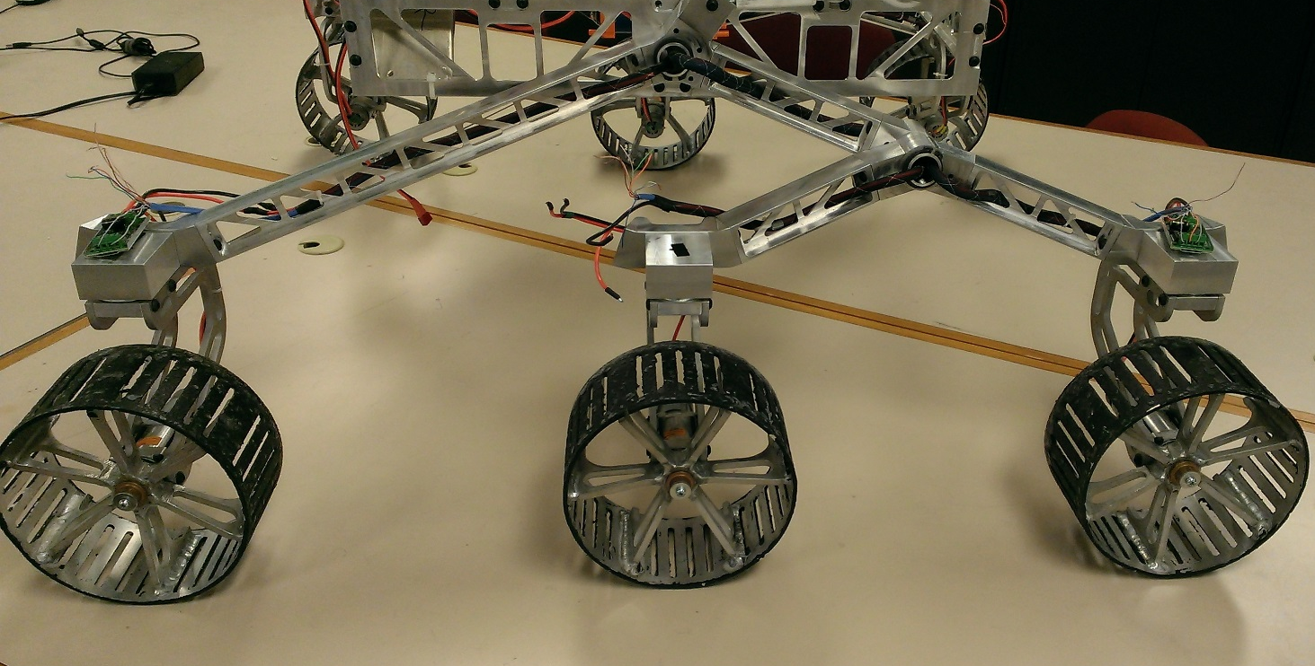
Figure 3: The new suspension system in a fabricated state.

1.3 Wheel Construction
In the previous model of MAVRIC, the team fabricated their own wheels. This was done by using large diameter aluminum tube for the outside surface of the wheel with welded spokes as internal support. The new wheel design makes use of liquid ABS plastic and an aluminum mold to create lighter weight wheels. In addition to the weight savings, the permanent aluminum mold can be used to create almost an infinite number of wheels. This means that making replacement wheels in the event of the wheels breaking would be very quick and easy.

IMAGES GO HERE!!!!

The wheels have not yet been fabricated. Currently the mold is in the process of being machined out. Once completed, the several sections of mold are bolted together and the 2 part liquid ABS is poured into the mold. The mold is then rotated to evenly distribute the plastic on the inside surface of the mold. This dries and is then removed from the mold. Once cured in an oven, the wheel is complete and the mold can be reused in order to create a new wheel.

1.4 Chassis Construction

1.5 Robotic Arm

1.6 End Effector
The end effector, at the beginning of the semester, was still in the design phase of the process. A general concept design had been made, shown in Figure, but little thorough design work had been done yet.

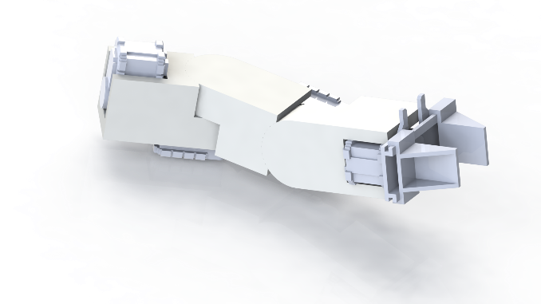
Figure 4: A previous conceptual design of the end effector

The end effector started the semester with a simple requirement of only lifting light loads for tasks, such as the soil sample task. However, due to rule changes, the end effector must now complete the payload deployment task as well. This task will require the end effector to be able to lift 5 kilograms, so we needed to adjust our requirements for our servos and bracket strength accordingly. This required our design to be stronger and able to withstand more stress, while at the same time keeping the overall weight and cost low. After several redesigns of the Solidworks assembly model, the end effector has a reasonable stress and displacement threshold, as shown through the stress testing done within Solidworks, and is now in the process of being manufactured by a CNC machine.
Currently, we have in our possession the three servos that will compose the End Effector. These three servos have been selected based on our estimated torque requirements for each rotational movement. The middle servo is slightly different than the other two since it has a larger torque output at 3600 ounces per inch versus the lighter 1200 ounces per inch. Both types of servos are shown below in Figure #.

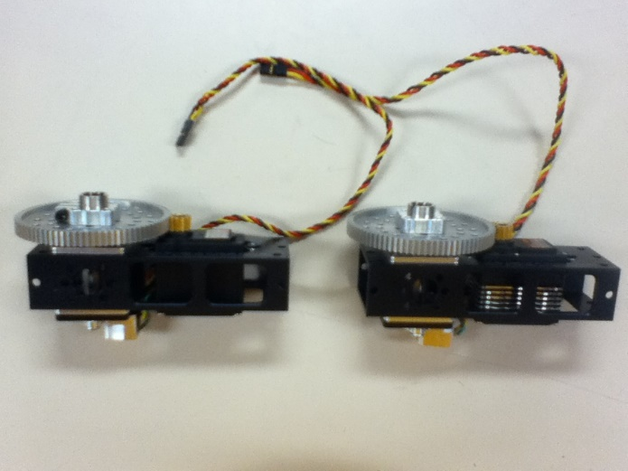
Figure #: The two types of servos used

This is necessary since the middle servo rotates the End Effector in the vertical plane. Due to this rotational plane, the servo has to fight gravity to a larger extent than the other two servos.
Also, we have designed the brackets used to connect the three servos together. The brackets will be made out of 70-75 aluminum and will be crafted in the CNC machines. The brackets have been designed to maximize durability and minimize weight while keeping the rotational axis along a common center. This will allow easier control over the End Effector by minimizing the confusion of multiple axis of rotation. Furthermore, due to the design of the brackets, the potential rotational movement is only limited in the vertical plane. Realistically, the End Effector will only need to rotate 180˚ horizontally and vertically. Due to some of the requirements of the tasks, having 360˚ of freedom of roll for the last servo will allow us to screw in pieces during the Construction task.
Going forward, there are three main objectives left to complete before competition. The first one is the manufacturing of the brackets used to connect all of the servos together. The designs for the brackets are complete so the last step is to take these designs to the CNC machines to be crafted. The second objective is to design and manufacture the part that will act as our gripper. This gripper will go on the end of the End Effector and will be used as a way for MAVRIC to interact with its environment during the competition tasks. Currently, we are looking at different designs used in industry to find one that we can accurately replicate with our own current materials. Thirdly, rigorous testing needs to be done on the End Effector. During and after the testing we will be evaluating the performance of the End Effector as a whole and each of the individual components. This will allow us to decide if each part has been manufactured to our specifications and if they will complete the required tasks at competition. If any of these parts do not meet the goals, we will have to redesign them with the remaining time and resources left to us. A model of the completed end effector is shown below for reference, in Figure #.
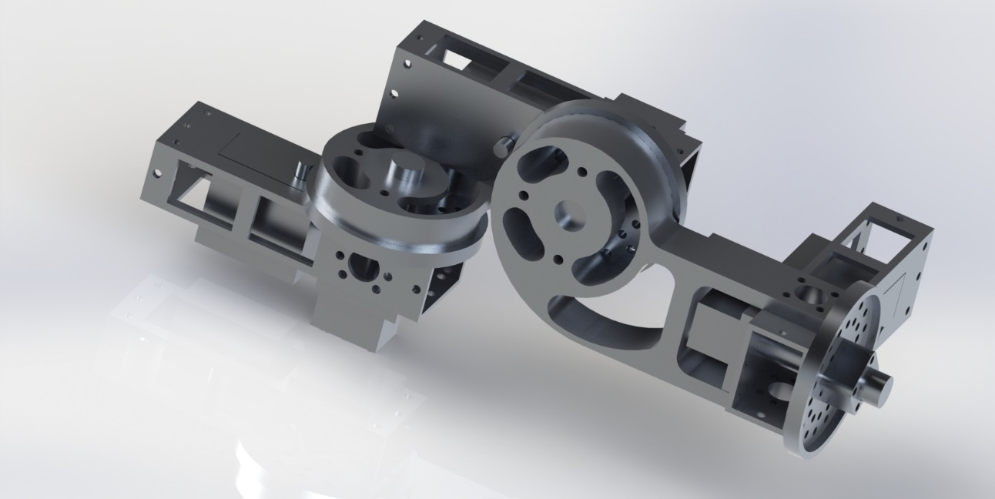
Figure #: Final design of the end effector

1.7 Gearbox Design

Part IV—Conclusion
MAVRIC as a whole has seen a great deal of change in the team structure and the rover design. Due to manufacturing defects that presented themselves during the World Space Week competition that the group attended, it was decided that the rover needed to be remanufactured. This decision took place midway through the first semester. Design updates started immediately and manufacturing started at the beginning of winter break. The rover progressed from design state to a mostly fabricated state at a rapid pace and by the end of the school year, the rover was able to drive and have basic control functionality.
Due to the necessary design changes so late in the year, the rover was not able to be completed in time to have it fully functioning and tested by the time competition arrived. In addition, budget constraints prevented the team from affording travel to the competition. The group, unfortunately, did not meet the goal of making to competition, but they were able to create a superior rover design that will make a great working platform to be used in future years.

1 Future Work
The group aims to finish the rover in the coming semesters and attend competition in the coming year. Since the rover is in a state that it is nearly completed, this is a more than realistic goal. In addition, starting from the point of fabrication that the team is at now will allow for more time in the coming semesters to refine the subsystem designs. This will also ensure that the rover is thoroughly tested prior to competition.

